Full Stack Development with MERN
Project Documentation
Hotel Pro – Hotel Booking and Management Website

1. Introduction
- Project Title: Hotel Pro – A Hotel Booking and Management Website
- Team Members: Tripur Shrivastava (sole developer)

2. Project Overview
- Purpose: Hotel Pro is a full stack web application built on the MERN stack (MongoDB, Express.js, React, Node.js). It lets guests search for hotels, check room availability and book rooms online, while giving hotel owners and administrators a single dashboard to manage rooms, bookings, pricing and guests. The goal is to replace manual, paper-based reservation handling with a fast, secure and easy-to-use digital system.
- Features: Key functionalities include:
  - User registration and login with secure authentication (JWT)
  - Search and filter hotels by city, price, rating, amenities and dates
  - Detailed hotel and room pages with images, facilities and reviews
  - Real-time room availability check and online booking
  - Booking history, modification and cancellation for users
  - Booking management: approve, cancel and track reservations

3. Architecture
- Frontend: The frontend is a single-page application built with React and bundled with Vite (configured in vite.config.js) for fast development and builds. It uses functional components and hooks (useState, useEffect, useContext), React Router for navigation, and Axios for API calls. Global state such as the logged-in user and search filters is handled with Context API (or Redux Toolkit). Styling is done with Tailwind CSS / Bootstrap for a responsive layout.
- Backend: The backend is a RESTful API built with Node.js and Express.js. The application is organized into models (Mongoose schemas), routes (API endpoints and their logic), middleware (authentication, validation, error handling) and utils (helper functions), with server.js as the entry point. Mongoose is used as the ODM to communicate with the database.
- Database: MongoDB stores all application data. The main collections are:
Collection | Key Fields
Users | name, email, password (hashed), phone, role, createdAt
Hotels | name, description, city, address, images, amenities, rating, owner
Rooms | hotel (ref), roomType, price, capacity, amenities, images, isAvailable
Bookings | user (ref), hotel (ref), room (ref), checkIn, checkOut, guests, totalPrice, status, paymentStatus
Reviews | user (ref), hotel (ref), rating, comment, createdAt

4. Setup Instructions
- Prerequisites: Software required to run the project:
  - Node.js (v18 or later) and npm
  - MongoDB (local installation) or a MongoDB Atlas account
  - Git
  - A code editor such as Visual Studio Code
  - Postman (optional, for testing APIs)
- Installation: Step-by-step guide to clone the project, install dependencies and set up environment variables:
Step 1: Clone the repository
git clone <repository-url>
cd hotel-pro

Step 2: Install server dependencies
cd server
npm install

Step 3: Install client dependencies
cd ../client
npm install

Step 4: Configure environment variables
Both the client and server folders contain a .env.example file. Copy each one to a new file named .env and fill in the values. The server .env should contain:
PORT=5000
MONGO_URI=mongodb://localhost:5173/hotelpro
JWT_SECRET=your_secret_key
JWT_EXPIRE=7d
PAYMENT_KEY=your_payment_gateway_key
The client .env should contain the backend API URL, for example:
VITE_API_URL=http://localhost:5000/api

5. Folder Structure
- Client: Structure of the React frontend (built with Vite):
  - src/ – React source code: components, pages, context/state, services (API calls) and the main App and entry files
  - node_modules/ – installed npm dependencies
  - index.html – root HTML file used by Vite
  - vite.config.js – Vite build and development server configuration
  - package.json and package-lock.json – project dependencies and scripts
  - .env.example – template for client environment variables
- Server: Organization of the Node.js backend:
  - middleware/ – authentication, role check, validation and error handling
  - models/ – Mongoose schemas (User, Hotel, Room, Booking, Review)
  - routes/ – Express route definitions for each resource
  - utils/ – helper functions (token generation, email, etc.)
  - node_modules/ – installed npm dependencies
  - server.js – application entry point (Express setup and database connection)
  - .env and .env.example – environment variables and its template
  - package.json and package-lock.json – project dependencies and scripts
- Root: .gitignore (files excluded from Git) and README.md (project overview).

6. Running the Application
Commands to start the frontend and backend servers locally:
- Frontend: npm run dev in the client directory (Vite dev server, runs on http://localhost:5173).
cd client
npm run dev

- Backend: npm start in the server directory (runs on http://localhost:5000).
cd server
npm start

7. API Documentation
All endpoints exposed by the backend are listed below. Protected routes require the header Authorization: Bearer <token>.
Method | Endpoint | Access | Description
POST | /api/auth/register | Public | Register a new user
POST | /api/auth/login | Public | Login and receive JWT
GET | /api/auth/me | User | Get logged-in user profile
GET | /api/hotels | Public | List hotels (query: city, minPrice, maxPrice, rating)
GET | /api/hotels/:id | Public | Get hotel details
POST | /api/hotels | Admin / Manager | Add a new hotel
PUT | /api/hotels/:id | Admin / Manager | Update hotel
DELETE | /api/hotels/:id | Admin | Delete hotel
GET | /api/rooms/:hotelId | Public | List rooms of a hotel
POST | /api/rooms | Admin / Manager | Add a room
POST | /api/bookings | User | Create a booking
GET | /api/bookings/my | User | Get user's bookings
PUT | /api/bookings/:id/cancel | User | Cancel a booking
GET | /api/bookings | Admin / Manager | View all bookings
POST | /api/reviews/:hotelId | User | Add a review

Example: POST /api/auth/login
Request body:
{
"email": "user@example.com",
"password": "123456"
}

Response (200 OK):
{
"success": true,
"token": "eyJhbGciOiJIUzI1NiIs...",
"user": { "id": "64f1c2...", "name": "John", "role": "user" }
}

Example: POST /api/bookings
Request body:
{
"hotel": "64f1a1...",
"room": "64f1b7...",
"checkIn": "2025-01-10",
"checkOut": "2025-01-12",
"guests": 2
}

Response (201 Created):
{
"success": true,
"booking": { "_id": "64f2d9...", "totalPrice": 7000, "status": "confirmed" }
}

8. Authentication
- Authentication is handled using JSON Web Tokens (JWT). When a user registers, the password is hashed using bcrypt before being stored in MongoDB.
- On login, the server verifies the credentials and returns a signed JWT containing the user id and role, valid for a limited period (e.g., 7 days).
- The client stores the token (in localStorage or an HTTP-only cookie) and sends it in the Authorization header with each request to protected routes.
- An Express authentication middleware verifies the token and attaches the user to the request object.
- Authorization is role-based: a role-check middleware restricts routes so that only Admins or Hotel Managers can manage hotels, rooms and all bookings, while regular users can access only their own bookings.
- On the frontend, protected routes redirect unauthenticated users to the login page.

9. User Interface
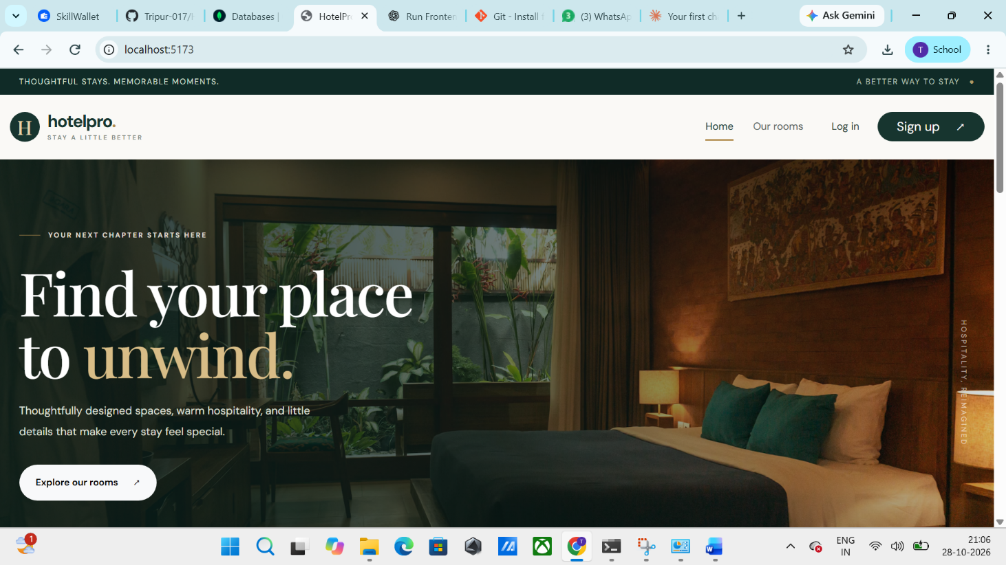

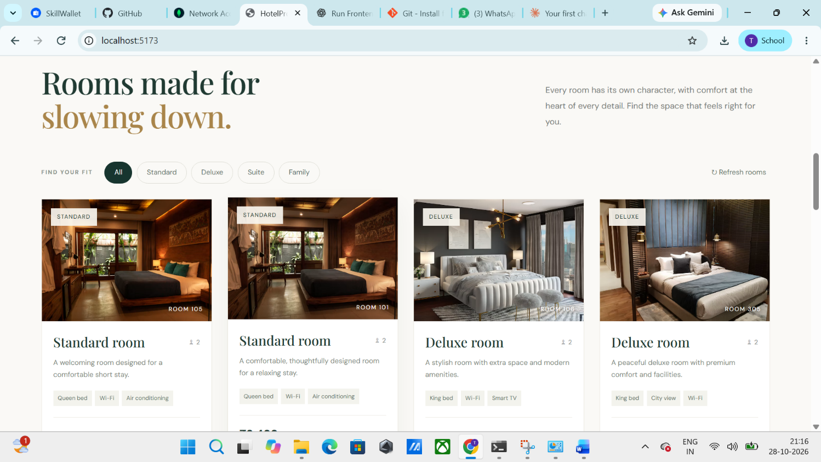

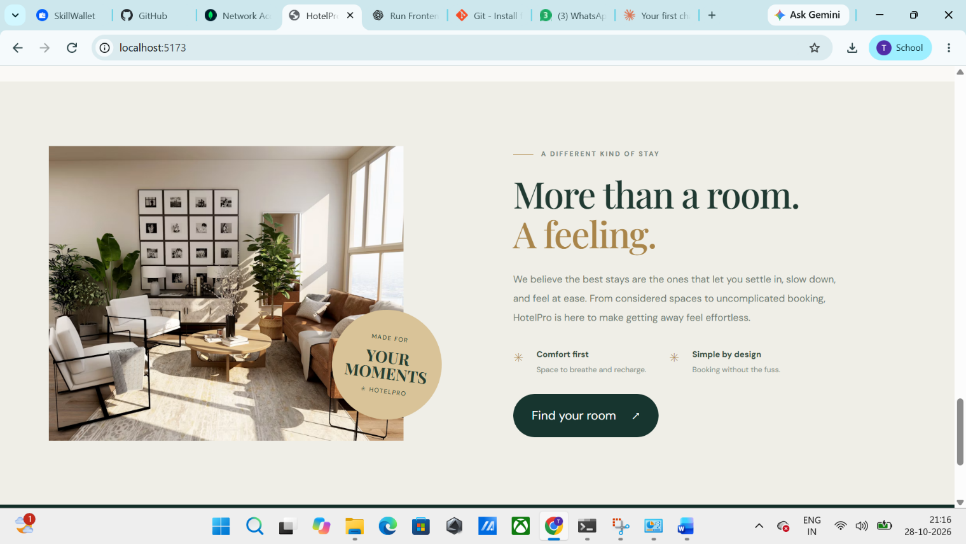

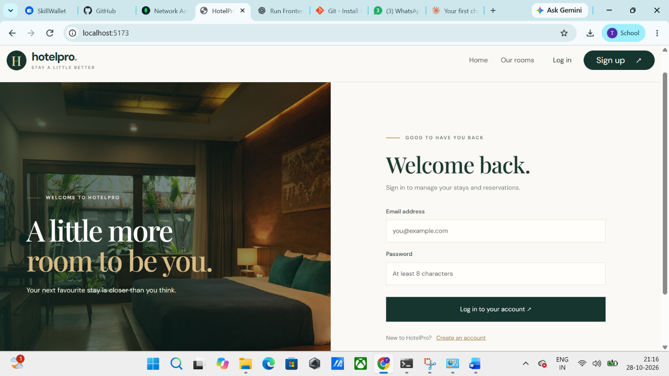

10. Testing
The testing strategy combines manual and automated testing:
- Unit testing: Jest is used to test backend utility functions and controller logic.
- API testing: Postman and Supertest are used to verify all endpoints, status codes and error handling.
- Frontend testing: React Testing Library with Jest is used to test components and user interactions.
- Manual / functional testing: End-to-end flows such as register, login, search, book, cancel and admin management are tested in the browser.
- Responsive testing: The UI is checked on different screen sizes using browser developer tools.

12. Known Issues
- Payment gateway runs in test mode only; live transactions are not yet enabled.
- Room availability is checked at booking time, so two users booking the same room at the same moment may cause a conflict.
- Image uploads are not compressed, which can slow down page loading on weak networks.
- Email notifications for booking confirmation may be delayed.
- Limited error handling for very large search results (pagination improvements pending).

13. Future Enhancements
- Mobile application using React Native
- Real-time availability and notifications using Socket.io
- Integration of live payment gateways and multiple payment options
- AI-based hotel recommendations and dynamic pricing
- Multi-language and multi-currency support
- Google Maps integration for hotel location and nearby attractions
- Loyalty points, coupons and discount offers
- Advanced analytics dashboard for hotel owners

